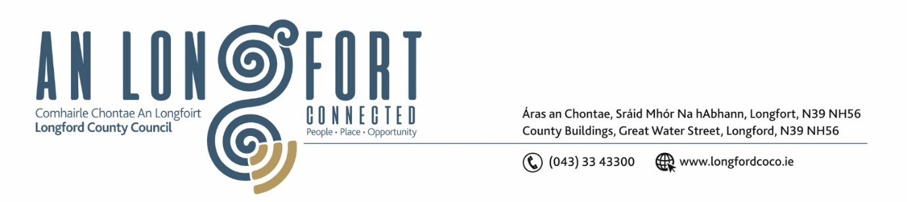

***LONGFORD MUNICIPAL DISTRICT***

***Please note meeting will be held via Microsoft Teams***

**20 January 2022.**

**To: Each Member of Longford Municipal District.**

**Dear Member,**

You are requested to attend the Meeting of Longford Municipal District to be held

**via Microsoft Teams** on **Wednesday 26 January 2022 at 3.30pm** to transact business, as set out on the Agenda hereunder.

**Yours sincerely**,

Ann Marie Mc Keon

_______________

**Ann Marie Mc Keon**

**Meetings Administrator.**

**AGENDA**

Prayer before meeting.

**1.** Confirmation of Minutes of Longford Municipal District Meeting held on Wednesday 24November 2021 – copy enclosed.

**2.** Matters arising from Minutes.

**3.** Declaration of Interest by Members.

**4.** Management Report - enclosed.

**5**. Proposed Projects/Expression of interests.

**6.** Presentation on Age Friendly Healthy Homes Programme.

**7**. Consideration and adoption of Draft Municipal District Report for inclusion in

Longford County Council 2021 Annual Report – enclosed.

**8.** Consideration of one Nominee for each of the 2020/2021 and 2021/2022

Cathaoirleach Awards.

**9.** Notices of Motions, submitted by Councillors, as listed hereunder –

**Councillor Gerry Hagan**

**(i) “**I call on Longford Municipal District to carry out a Low-Cost Safety Schemeon the Micknagh/Drumhaughley Road. The sides of this road are currently in a very dangerous state. It is a major safety issue on this very busy road, and all who use this road are greatly endangered in going off road when meeting oncoming traffic.

There is also a major hazard for Motorists driving Tractors, Buses and Lorries, whereby the trees are seriously encroaching on the road from both sides and are in fact forming a canopy over the road. There is a drop of more than fifteen feet on both sides of the road which has been the scene of a number of very near misses recently. Both sides of the road needs to be built up so as to avoid cars going off road and down into the steep ravines.

(ii) “I call on Longford Municipal District to restructure the recently installed ramp beside The Mall**.** This new ramp is causing a lot of distress to all road users since its installation.

The ramp should be restructured and redesigned and aligned with the other ramps on the road so as there is a consistency with the other ramps on this road for all road users. In its current state, the ramp has been described to me by a large number of motorists as like, ‘hitting a wall in the middle of the road’.

(iii) “I call on Longford Municipal District to cut down the hedge along the carton road and around the corner in the direction of Cullyfad. This is to help all road users to have a clear line of sight as the approach the junction at Carton and want to turn right towards Cullyfad.

**Councillor Uruemu Adejinmi**

“I call on Longford County Council to conduct an inspection of footpaths in Glack and carry out upgrade works on the footpaths as needed”.